**MARKETPLACE FOR EDUCATIONAL SERVICES**

**‘EduBazar’**

Project Phase II Synopsis

**MASTER OF COMPUTER APPLICATIONS**

**(4th Semester)**

*Submitted by*

**DINESH SINGH**

Batch-2023-2025

Enrollment No.-U2046035

*Under the Supervision of-* **Ms. SUNITA TRIPATHI**

## uoa.png

**Centre of Computer Education & Training**

**Institute of Professional Studies**

**University of Allahabad, Prayagraj**

**Uttar Pradesh – 211002**

**TABLE OF CONTENTS**

1. INTRODUCTION…………..…………………………….………….…..……….…1-3

1.1 Problem Definition

1.2 Motivation

1. OBJECTIVE………………..…………………………...…...…………..……………..4
2. GOALS………………………………………………………………...……………….5
3. REQUIREMENT ANALYSIS AND SPECIFICATIONS…….......................……...6-9
   1. Functional Requirements
   2. Non-Functional Requirements
   3. Technical Requirements
   4. Software & Hardware Requirements
4. SYSTEM DESIGN………………………………………………………..……....10-14

4.1. DFD (Data Flow Diagram)

1. DEVELOPMENT & TESTING……………………….…………...............................15
2. MILESTONES……………………………..………………………...………….........16
3. MEETINGS WITH THE SUPERVISOR…………………………...…………..…….17
4. REFERENCES…………………………………...………………………......….........18

**INTRODUCTION**

**EduBazar** will be developed to connect individuals who will seek educational services with skilled professionals who will offer them. The objective of this platform will be to enable clients to discover, book, and procure a wide range of services such as tutorials, graphic designing, and application development. At the same time, it will empower service providers to showcase their expertise and manage bookings efficiently.

This project will focus on creating a user-friendly and secure web platform that will facilitate seamless interactions between service providers and clients. **EduBazar** will utilize modern technologies to ensure scalability, data security, and smooth operations. By introducing features such as advanced search, real-time booking, and a review system, EduBazar will aim to simplify the process of accessing and delivering educational services, making it a reliable hub for educational needs.

**Project Title:** ‘**EduBazar’** (Marketplace for Educational Services)

**Category:** Web Development

**PROBLEM DEFINITION**

In the current scenario, individuals seeking educational or skill-based services face challenges in finding reliable service providers. Traditional methods of searching through advertisements or referrals are often time-consuming and lack transparency regarding the quality and credibility of the services offered. Similarly, skilled professionals face difficulties in reaching their target audience and showcasing their expertise effectively.

Existing platforms may lack specialized focus on educational services, leading to a cluttered experience with irrelevant offerings. Moreover, the absence of streamlined processes for booking, secure payments, and real-time communication results in inefficiencies and a lack of trust between service providers and clients.

For instance, clients might struggle to compare multiple service providers based on their skills, experience, and pricing. On the other hand, service providers may not have the tools to highlight their unique capabilities, manage client interactions, or receive constructive feedback. This gap creates a pressing need for a dedicated, well-organized platform that caters exclusively to educational services, ensuring ease of use, transparency, and mutual trust.

**EduBazar** will aim to address these issues by creating a marketplace that will simplify the process of discovering, booking, and availing educational services while empowering providers to showcase their skills and build their reputation in a secure and transparent environment.

**MOTIVATION**

**EduBazar** will be driven by the need to bridge the existing gap between clients seeking educational services and skilled professionals offering them.In the traditional landscape, individuals often face challenges in finding reliable service providers, especially in the educational domain, where quality, transparency, and efficiency are crucial. Existing platforms are often cluttered, and the search for educational services becomes a time-consuming task without a centralized and organized approach. Moreover, service providers struggle to showcase their skills and connect with clients effectively.

The motivation behind **EduBazar** is to create a specialized marketplace that focuses exclusively on educational and skill-based services, ensuring that both clients and providers have a streamlined, secure, and transparent platform to interact. By introducing advanced features such as real-time bookings, secure payments, review systems, and categorized listings, **EduBazar** will aim to eliminate the inefficiencies of traditional methods of finding educational services, making the entire process smoother, more trustworthy, and accessible for everyone involved.

**EduBazar** will strive to address the challenges faced in the educational services space. It will aim to remove the obstacles related to service discovery, booking processes, and transparent interactions, empowering clients and service providers alike. The platform’s goal will be to simplify the search, comparison, and procurement of educational services while helping professionals build their reputation and establish themselves in a secure, user-friendly environment.

**OBJECTIVE**

**EduBazar** will aim to create a secure, efficient, and user-friendly platform that will connect clients with skilled professionals offering educational services. It will ensure seamless accessibility for discovering, booking, and availing services while empowering providers to showcase their expertise and manage bookings effectively. With advanced search filters, real-time availability, secure payments, and a review system, **EduBazar** will streamline processes, build trust, and foster transparency. Prioritizing security and scalability, it will safeguard user data and accommodate growth without compromising performance, offering a customized and reliable marketplace for both clients and service providers.

**GOALS**

The main goals of this project are:

1. **Centralized** **Marketplace:** Build a platform connecting clients with educational and skill-based service providers.
2. **Enhanced** **User** **Experience:** Create a user-friendly interface for seamless navigation and bookings.
3. **Trust** **and** **Transparency:** Implement reviews and ratings to ensure accountability and quality services.
4. **Empower** **Providers:** Enable professionals to showcase expertise and manage bookings efficiently.
5. **Streamlined** **Processes:** Simplify service discovery and bookings with advanced tools and real-time updates.
6. **Security:** Protect user data and payments with secure authentication and encryption.
7. **Customization:** Offer personalized profiles and tailored listings for better user relevance.
8. **Scalability:** Design the platform to handle growth without compromising performance.
9. **Real**-**Time** **Communication:** Integrate messaging for seamless client-provider interactions.
10. **Continuous** **Improvement:** Monitor feedback and update features to enhance functionality.

**REQUIREMENT ANALYSIS AND SPECIFICATIONS**

**Functional Requirements**

* **User Registration and Authentication:** Users (both clients and service providers) must be able to register, log in, and manage their profiles securely using modern authentication mechanisms like email/password or social media login options**.**
* **Service Listings:** Service providers should be able to list their services with detailed descriptions, pricing, and availability. Services should be categorized into different educational subdomains such as tutorials, design, development, etc.
* **Advanced Search and Filters:** Clients should be able to search for services using multiple filters like price range, location, ratings, and service category to find the most relevant options.
* **Real-Time Booking:** Clients should be able to book services based on the real-time availability of service providers. The system should automatically update bookings and sync with service providers' schedules.
* **Payment Gateway Integration:** A secure payment gateway must be integrated to handle transactions, ensuring that both clients and service providers are paid promptly and securely.
* **Review and Rating System:** Clients should be able to leave feedback, ratings, and reviews for the services they availed, helping build trust and transparency on the platform.
* **Messaging System:** A direct messaging system for clients and service providers to communicate about services, bookings, or any clarifications**.**
* **Django Admin Panel:** The Django admin (built-in interface for managing database models, allowing CRUD operations and administrative tasks through a user-friendly web interface) must be able to manage user accounts, approve or reject service listings, monitor transactions, resolve disputes, and ensure compliance with platform policies.
* **User Profiles:** Both clients and service providers should have profiles to track orders, manage favourites, update their listings, and showcase testimonials or portfolios (for service providers).

**Non-Functional Requirements**

* **Performance:** The platform must handle high traffic efficiently, providing quick response times when browsing, booking, and making payments.
* **Usability:** The platform should have an intuitive and easy-to-navigate interface that caters to both tech-savvy users and beginners. It should offer a responsive design for users on desktop, tablet, and mobile devices.
* **Scalability:** The system should be designed to scale as the number of users and services grows without compromising on performance. This includes handling increased traffic, service listings, and data storage.
* **Security:** Ensure robust security measures for protecting sensitive user data, such as encrypted passwords, secure payment processing, and protection against unauthorized access. Compliance with data protection laws (e.g., GDPR) should also be a priority.
* **Compatibility:** The platform should be compatible with various web browsers (Brave, Chrome, Firefox, Safari, etc.) and operate smoothly across different operating systems (Windows, macOS, Linux).
* **Maintainability:** The system should be built with easy-to-maintain code, allowing for simple updates, bug fixes, and future feature enhancements. Comprehensive documentation should be available for developers.
* **Backup and Data Recovery:** Regular backups of user data and transaction logs should be in place, ensuring that data can be restored in the event of a failure or data loss incident.
* **Accessibility:** Ensure the platform meets accessibility standards, providing features such as text-to-speech for visually impaired users and easy navigation for users with disabilities.

**Technical Requirements**

1. **Frontend Technologies**

* **HTML:** Creating Structure and markup for webpages.
* **CSS:** Styling and layout using Custom CSS.
* **JavaScript:** Client-side scripting for interactive features and game logic.
* **Bootstrap:** Framework for more prebuilt features for defining interactive UI.

1. **Backend Technologies**

* **Django:** Framework for building the backend, handling routing, and interacting with the database.
* **Database:** SQLite for storing user data, game data, and performance metrics.
* **ORM:** Django’s ORM (Object Relational Mapping) for database interactions.

.

**SOFTWARE & HARDWARE REQUIREMENTS**

**Hardware Required:**

**Name of Components Specifications**

Processor : Intel/AMD/Ryzen

RAM : 4GB or More

Speed : 1.00 GHz

System Type : 64-bit operating system

**Software Required:**

**Name of Components Specifications**

Operating System : Windows/Mac/Linux

Frontend : HTML, CSS, JavaScript

Framework **:** Django, Bootstrap

Database **:** SQLite

IDE **:** Visual Studio Code

Browser **:** Chrome/Mozilla/Edge/Brave

**SYSTEM DESIGN**

Detailed System design of **EduBazar** using Data Flow Diagram (DFD):

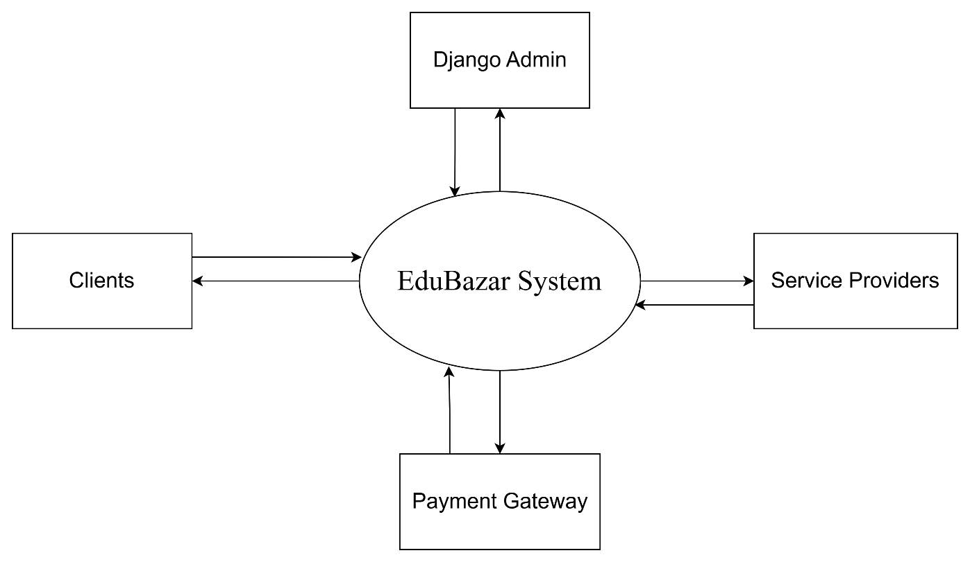**Level-0**

**Level-1**

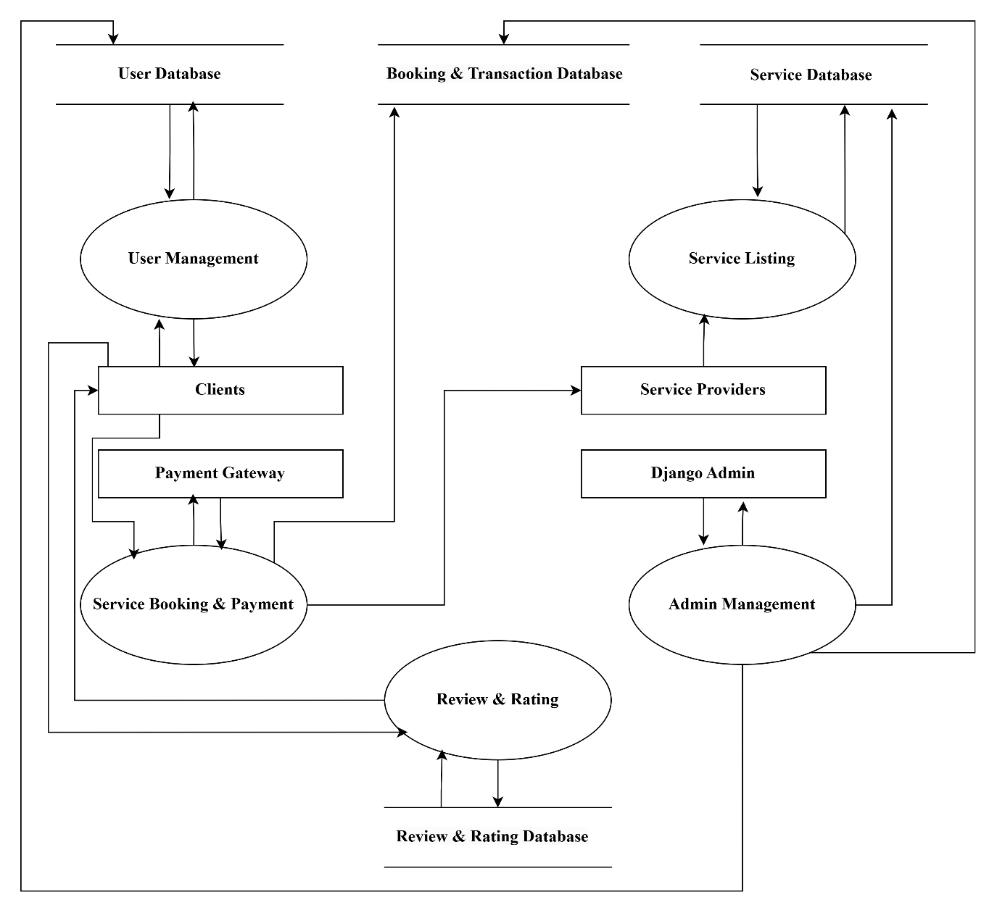

**Level-2**

**User Management**

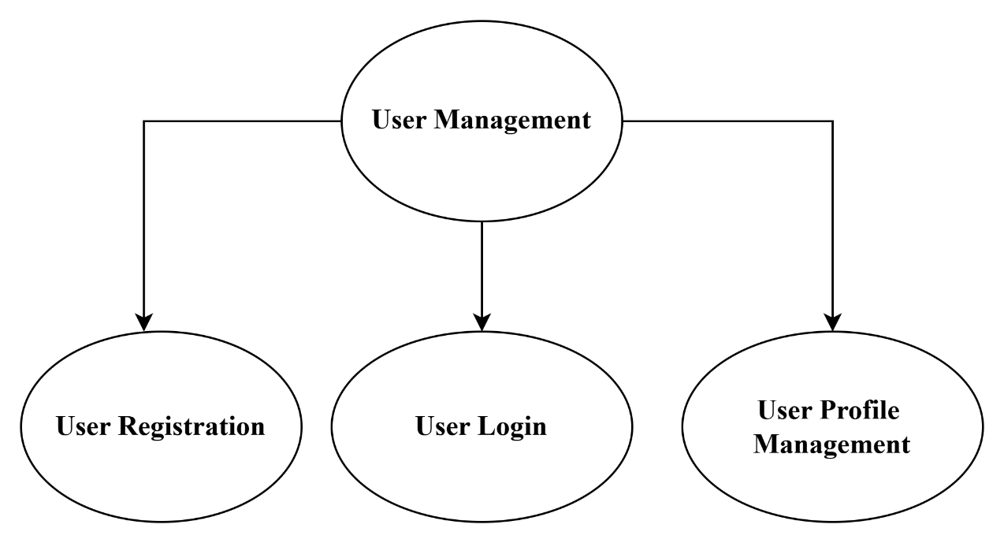

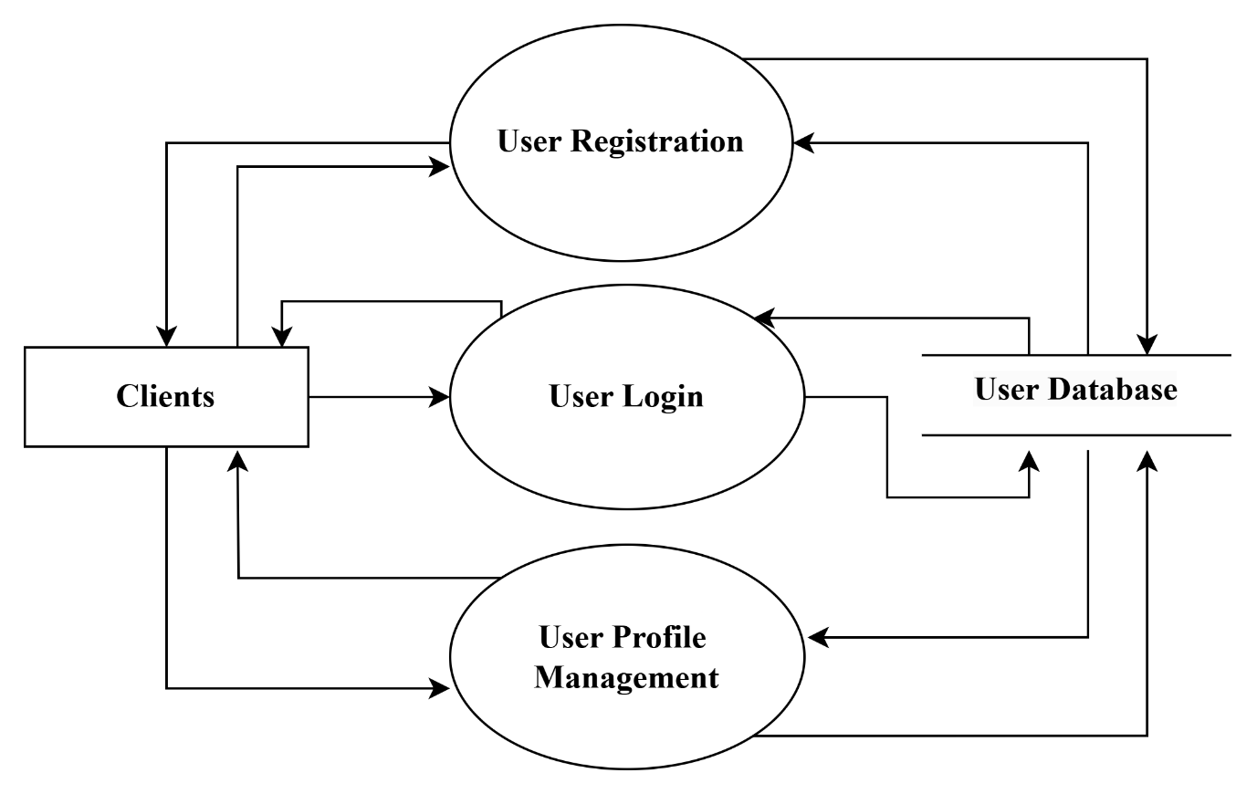

**Service Listing**

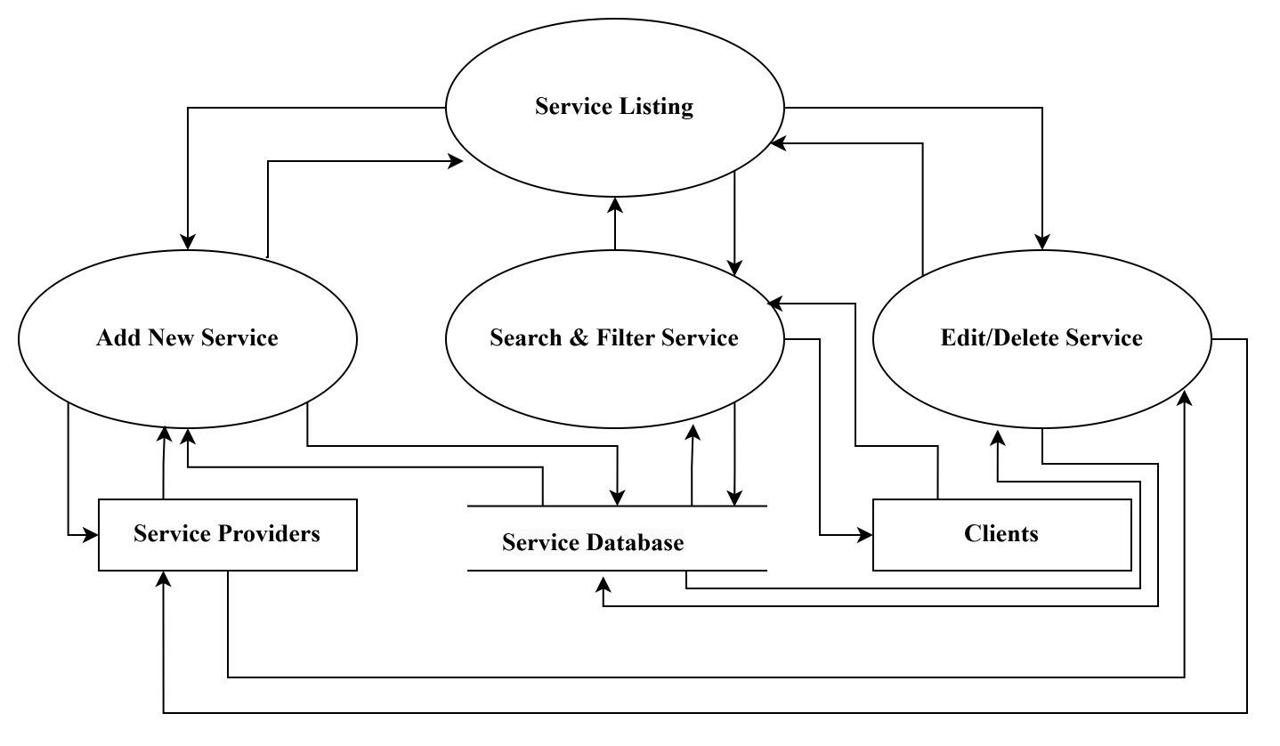

**Service Booking & Payments**

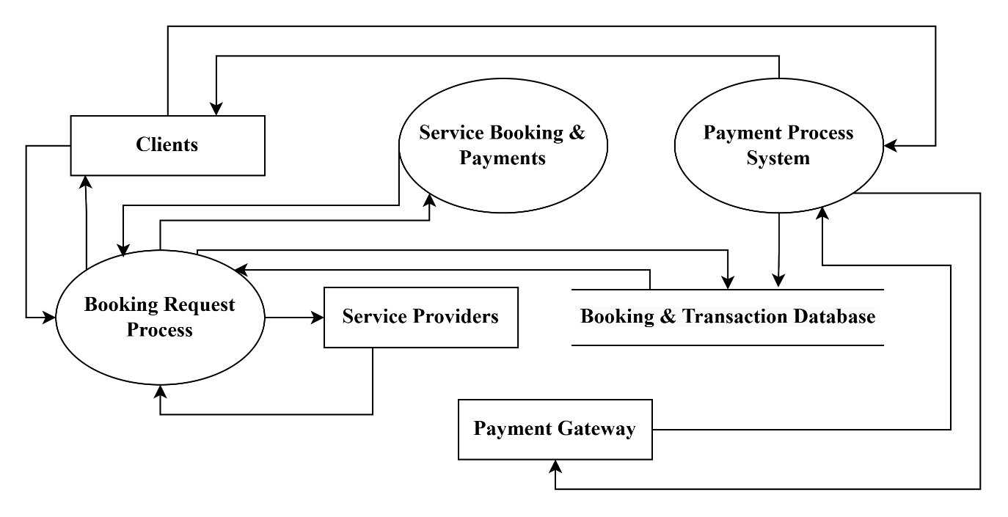

**Review & Rating**

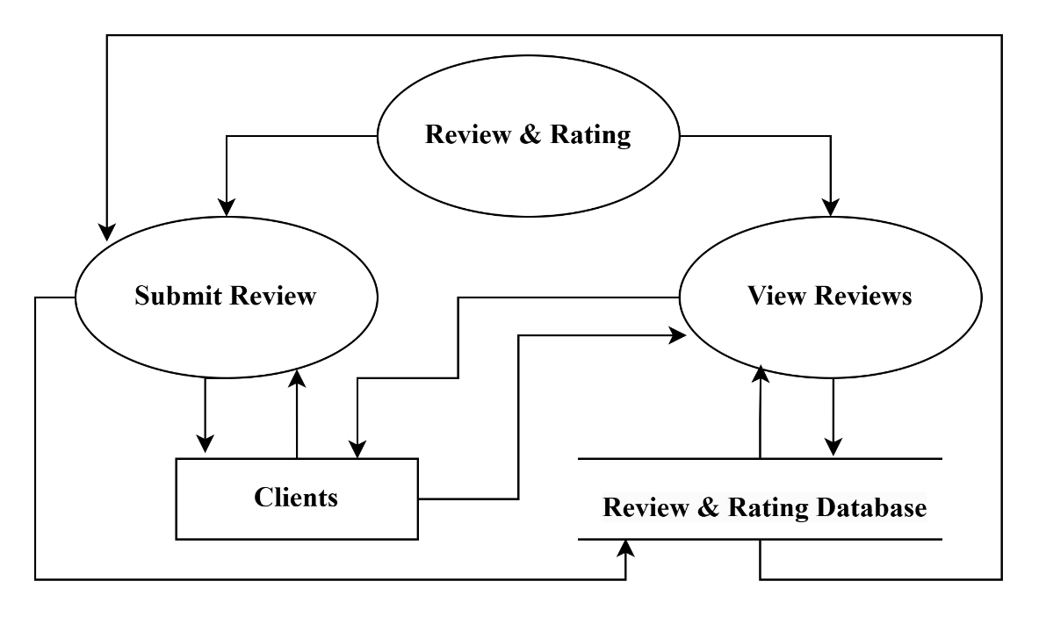

**Admin Management**

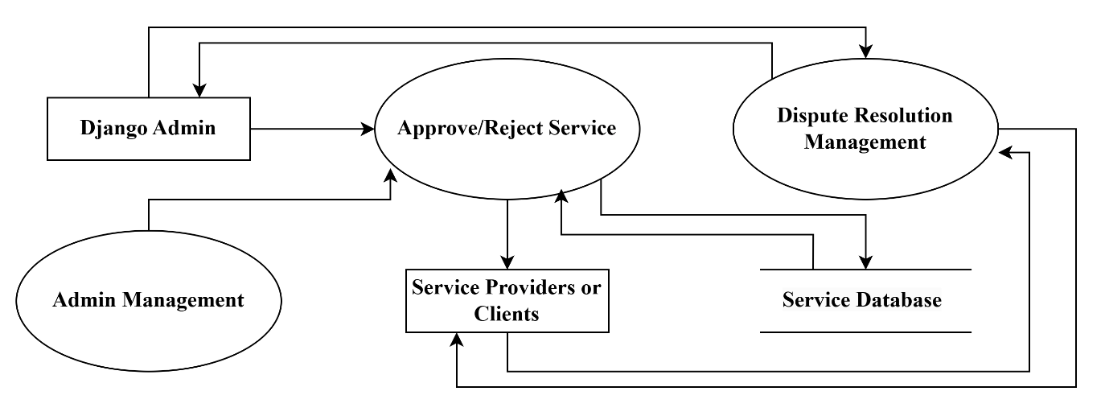

**DEVELOPMENT & TESTING**

The development phase will follow an agile methodology, with iterative cycles of planning, development, and testing. Key activities will include:

* **Development:** Writing and integrating code based on the specified requirements and design.
* **Testing:** Conducting unit tests, integration tests, and user acceptance tests to ensure functionality, performance, and security.
* **Deployment:** Deploying the website to a production environment and ensuring it is fully operational.
* **Maintenance:** Providing ongoing support and updates based on user feedback and emerging requirements.

**MILESTONES**

|  |  |  |  |
| --- | --- | --- | --- |
| **Sr. No** | **Project activity** | **Estimated Start Date** | **Estimated End Date** |
|  | Project Allotment | 08/01/2025 | 11/01/2025 |
|  | Requirement Gathering | 11/01/2025 | 15/01/2025 |
|  | Synopsis Creation | 15/01/2025 | 23/01/2025 |
|  | Synopsis Submission | 24/01/2025 | 24/01/2025 |
|  | Designing | 25/01/2025 | 05/02/2025 |
| 6. | Development | 06/02/2025 | 28/02/2025 |
| 7. | Testing | 01/03/2025 | 07/03/2025 |
| 8. | Finalizing the Project | 08/03/2025 | 12/03/2025 |

**MEETINGS WITH THE SUPERVISOR**

|  |  |  |  |
| --- | --- | --- | --- |
| **Date of the meet** | **Mode** | **Comments by the supervisor** | **Signature of the supervisor** |
| 10/01/2025 | Offline | Project topic discussions |  |
| 22/01/2025 | Offline | Minor correction in Synopsis |  |
| 23/01/2025 | Offline | Checked the revised Synopsis and approved for presentation |  |

**REFRENCES**

1. **Levels in Data Flow Diagrams (DFD)- GeeksforGeeks**

<https://www.geeksforgeeks.org/levels-in-data-flow-diagrams-dfd/>

This page provides an introduction to Data Flow Diagram (DFD) and explains different levels (Level 0, Level 1, etc.) used to represent data flow at varying degrees of detail in a system.

1. **Diagrams.net (Formerly Draw.io)**

<https://app.diagrams.net/>

Diagrams.net, also known as Draw.io, is an online tool used for creating a variety of diagrams like flowcharts, network diagrams, and DFDs. It’s widely used for system design and project documentation.